2200031128 CH.BHAVANA
WEEK 5 Hands on:
Creating Micro-Services for Account and Loan
Task Description: Creating Microservices for Account and Loan
Creating Microservices for account and loan in these hands-on exercises, we will create two microservices for a bank. One microservice for handing accounts and one for handling loans. Each microservice will be a specific independent Spring RESTful Webservice maven project having its own pom.xml. The only difference is that, instead of having both account and loan as a single application, it is split into two different applications. These webservices will be a simple service without any backend connectivity.
1. CREATE ACCOUNT MICROSERVICE:
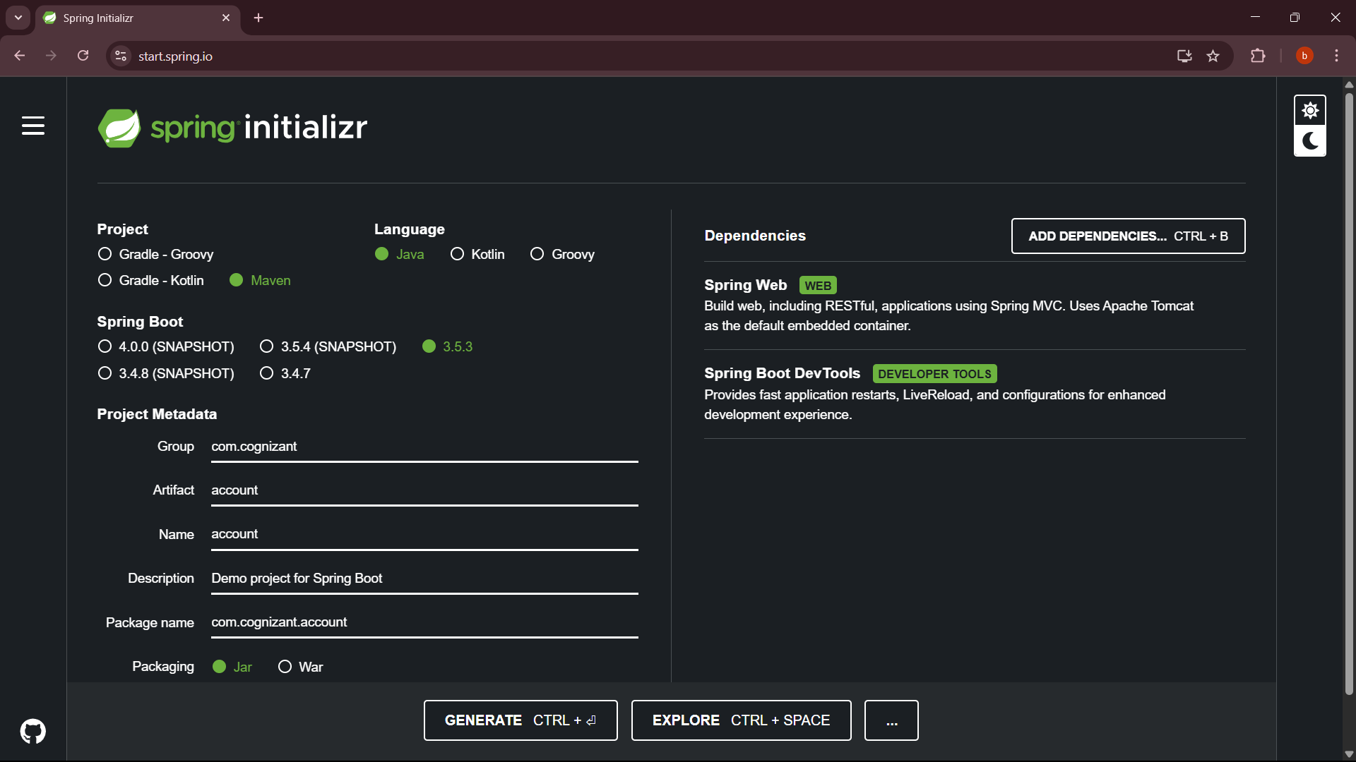
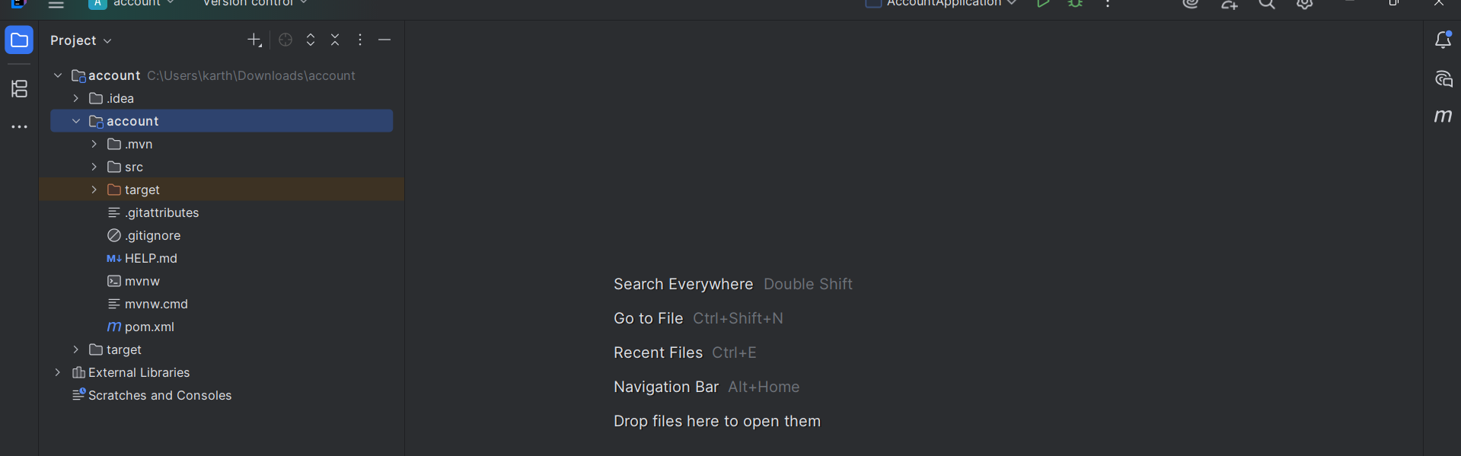
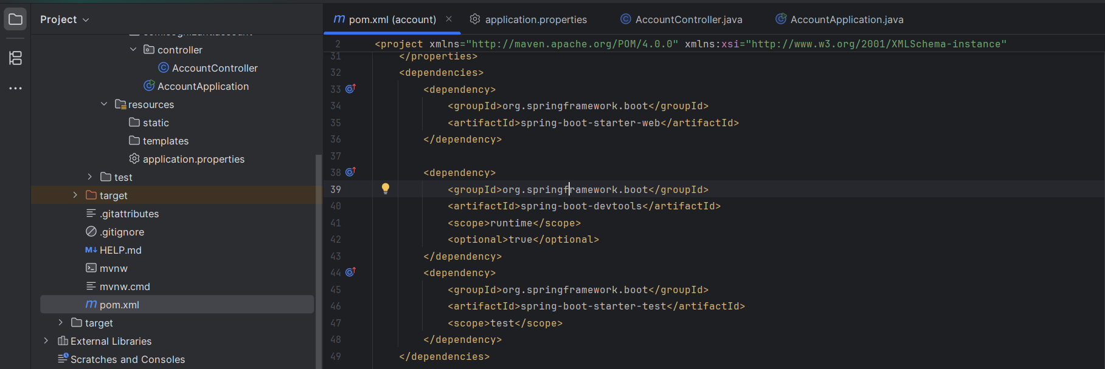
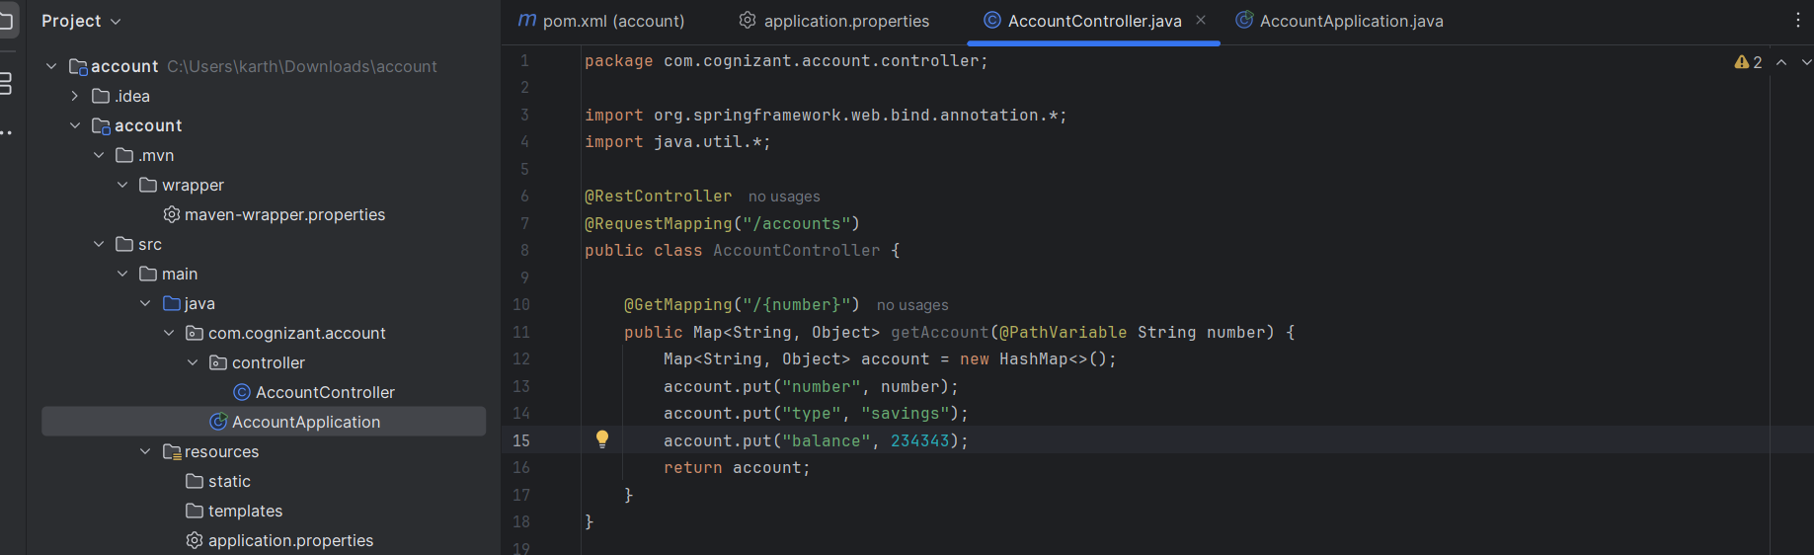
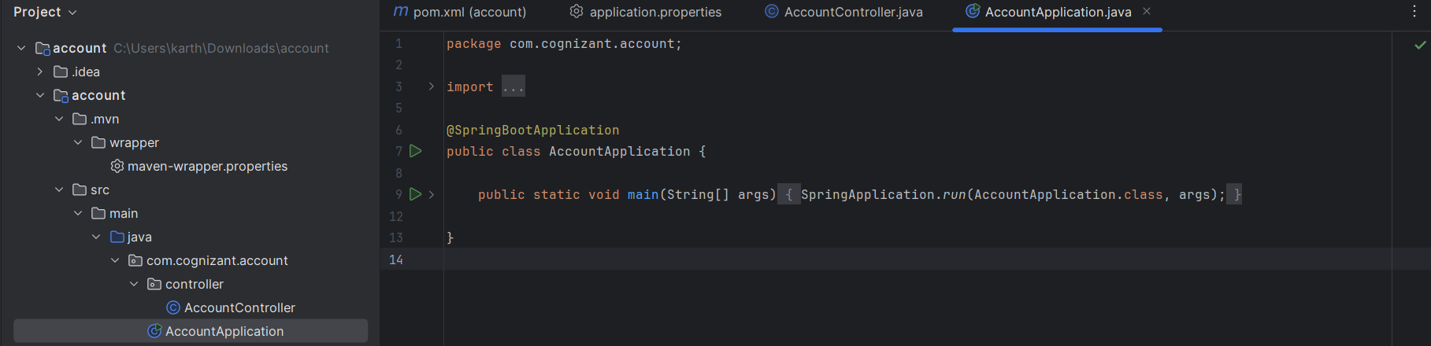
OUTPUT:
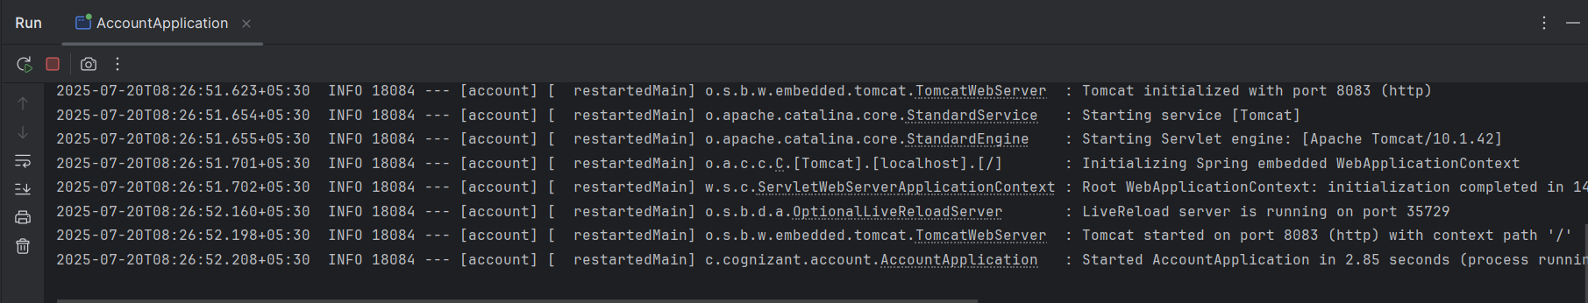
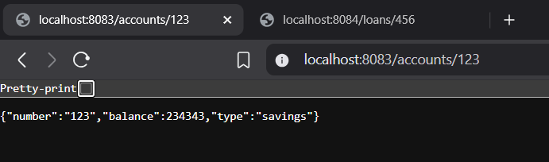
2. CREATE LOAN MICROSERVICE:
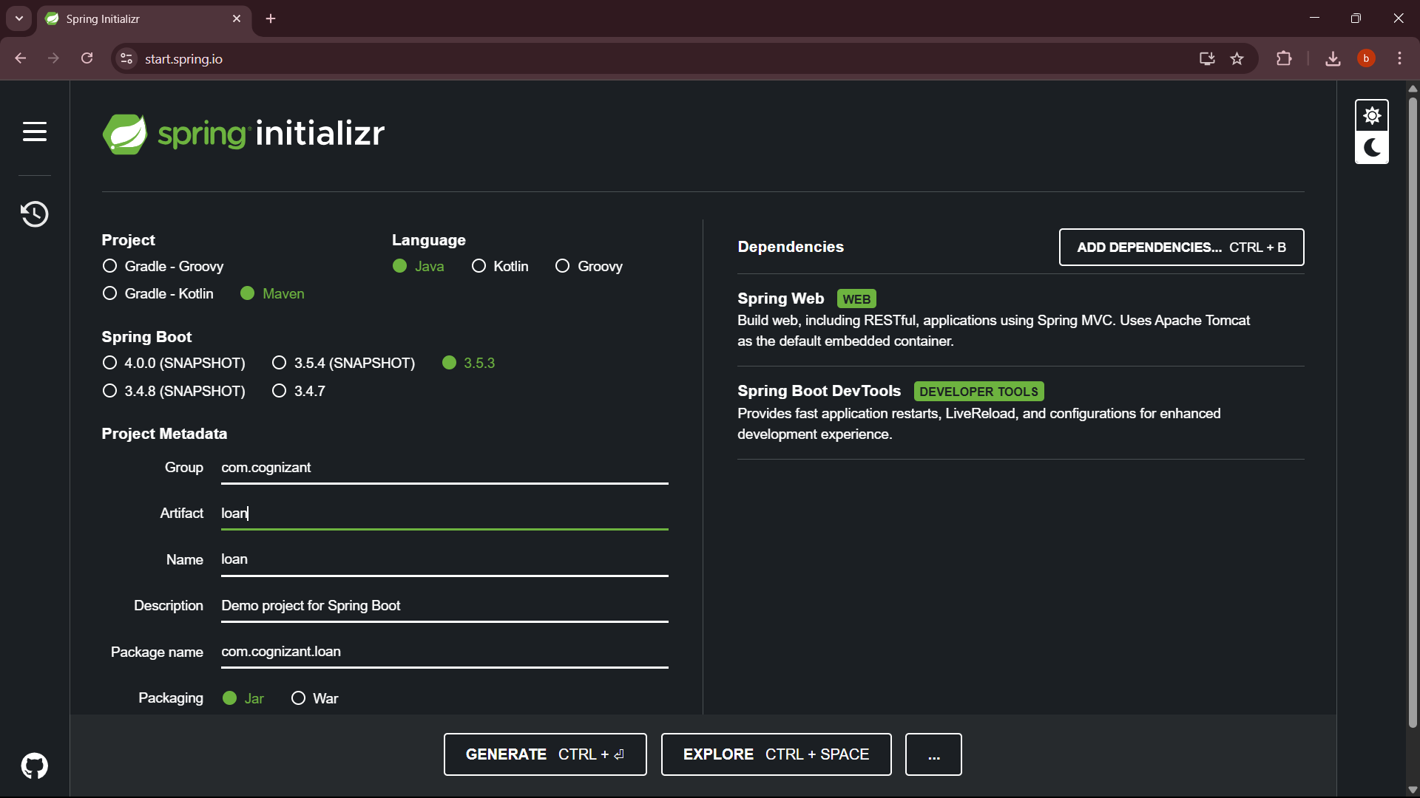
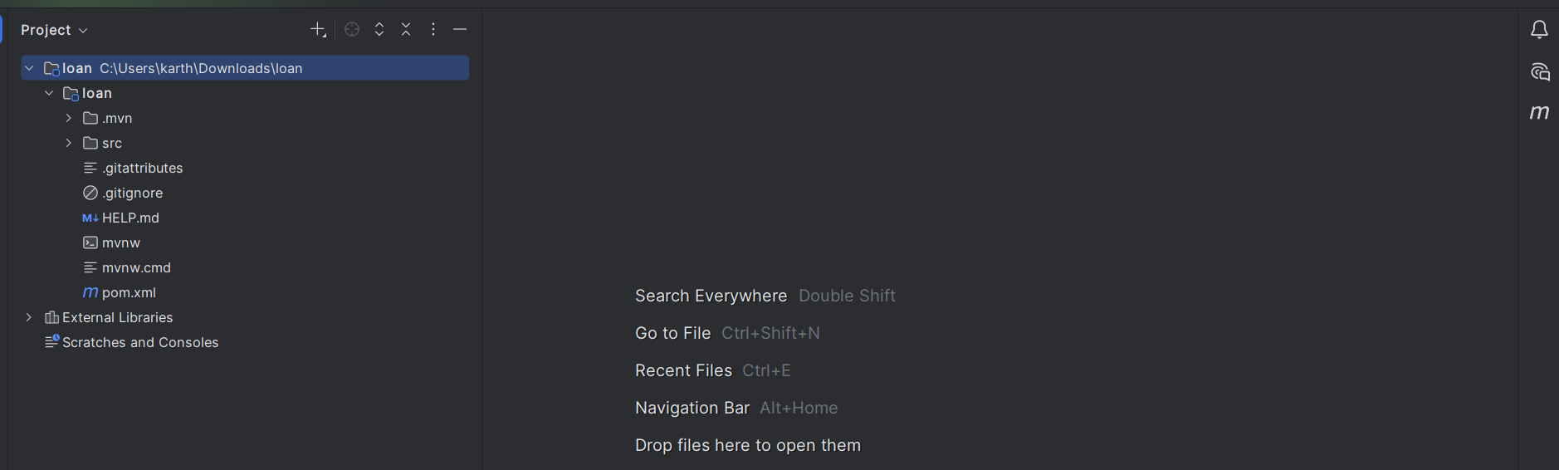
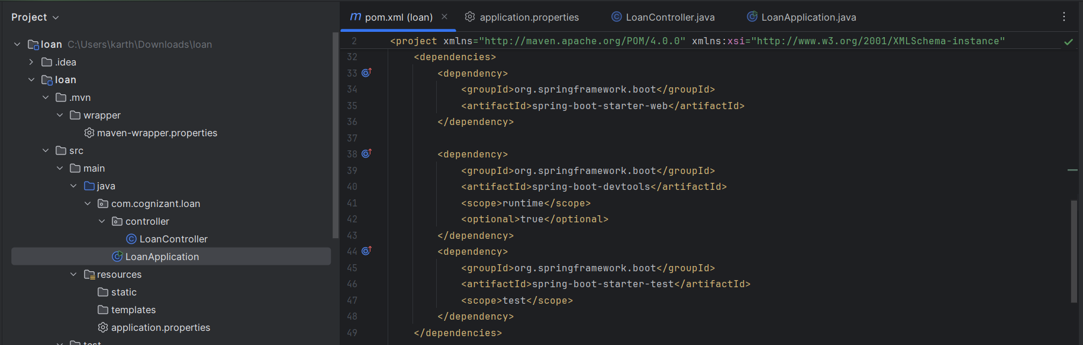
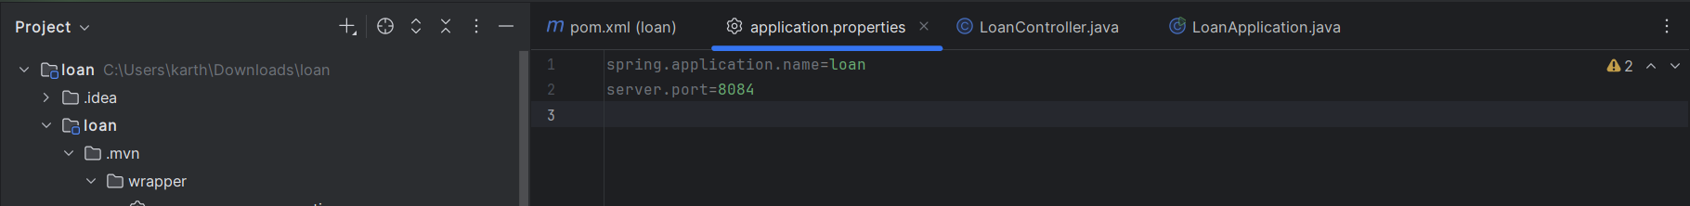
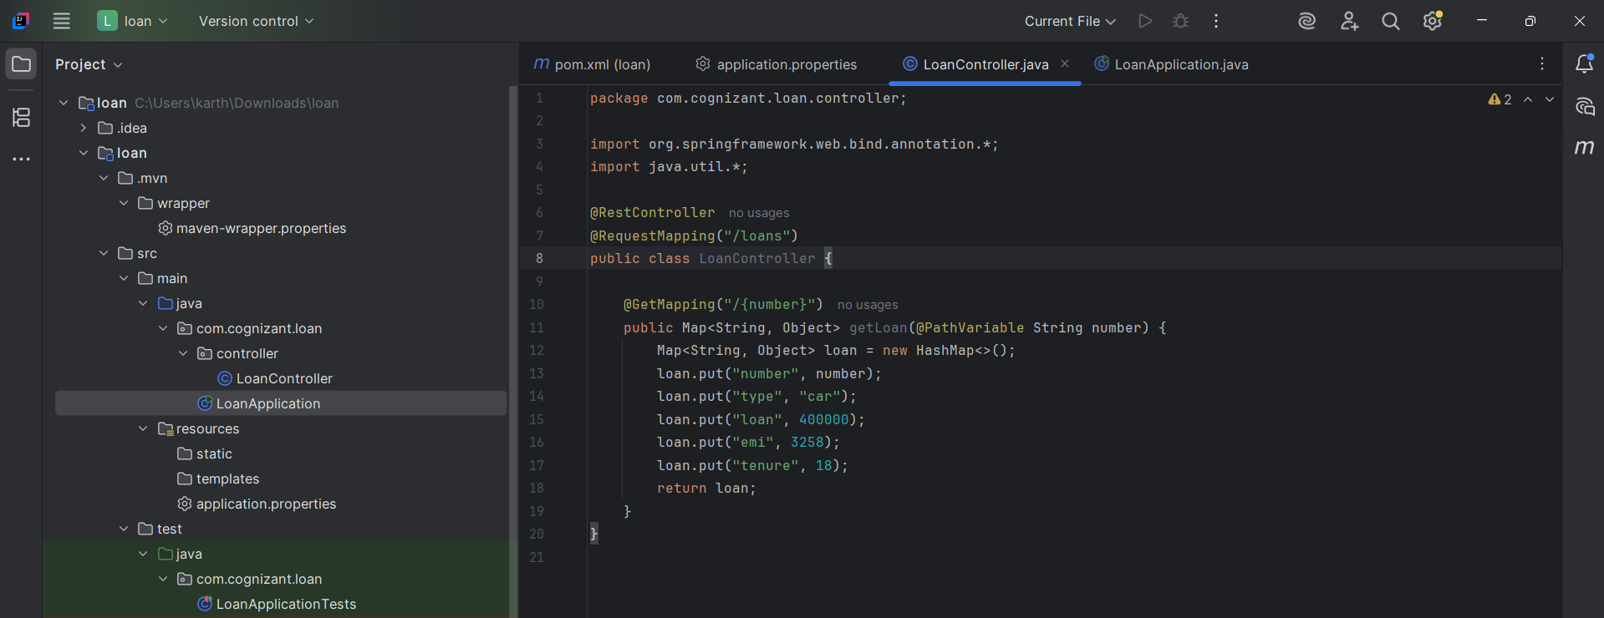
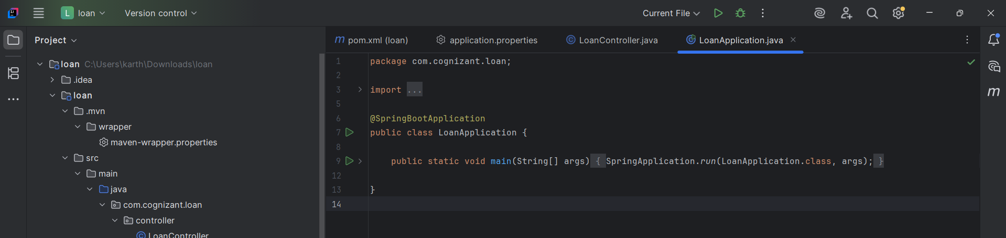
OUTPUT:
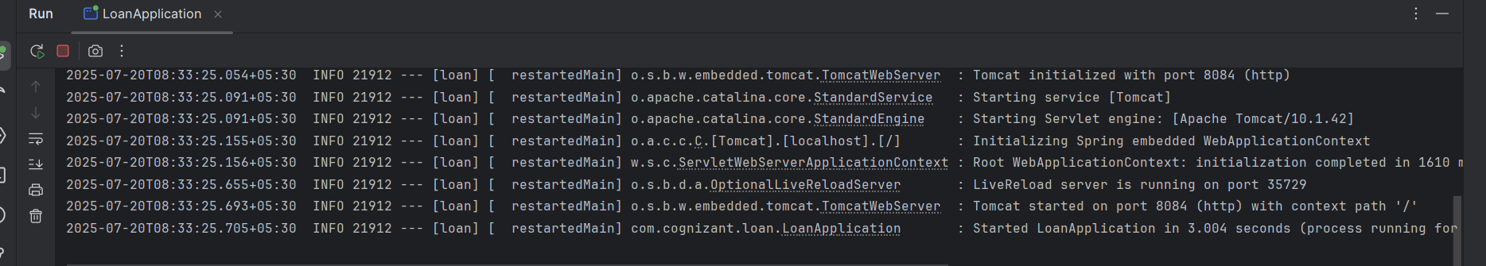
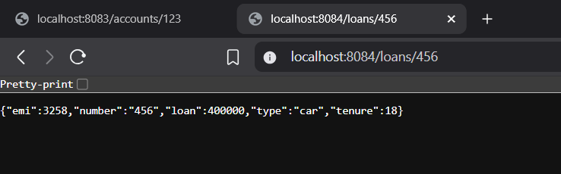
1. Microservice Architecture Approach
- We followed a microservice design pattern, where each service is developed and deployed independently.
- The account and loan services have their own:
  - Source code
  - Build configuration (pom.xml)
  - Port configuration
  - Controller endpoints
2. Project Generation Using Spring Initializr
- Used start.spring.io to bootstrap each project.
- Selected:
  - Project type: Maven
  - Language: Java
  - Java version: 24
  - Dependencies: Spring Web, Spring Boot DevTools
- Generated and downloaded a ZIP file for each service (account and loan), extracted and opened in IntelliJ.
3. Project Setup and Configuration
- Each microservice had its own:
  - application.properties with unique server.port and spring.application.name
  - Main application class annotated with @SpringBootApplication
- Ports were set to avoid conflict:
  - Account service: 8083
  - Loan service: 8084
4. Controller Development
- Created REST controllers in both services:
  - AccountController.java → /accounts/{number}
  - LoanController.java → /loans/{number}
- Used @RestController, @RequestMapping, and @GetMapping to expose endpoints.
- Returned hardcoded JSON-like responses using a Map.
5. Running and Testing the Applications
- Each application was run from IntelliJ using the main() method.
- Services were accessed via browser using their respective URLs.
- The endpoints returned expected static JSON responses for demo/testing purposes.

